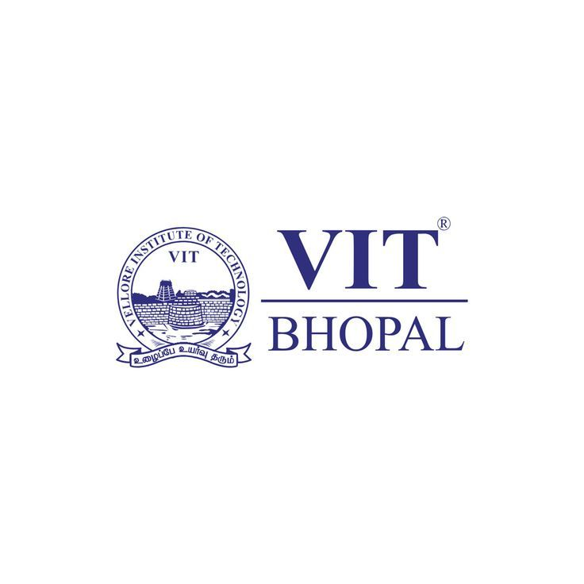

Project Report on
Digital Literacy
Int. Mtech 1st Year
(Branch - AI and Bioinformatics)

Submitted To: Submitted By:
Dr. Kannan Siddhika Namdeo

Course Code: CSE0001 Date of Submission: 31st March 2026
ACKNOWLEDGEMENT

This Project report was completed as a result of support from many people, although not all of them can be mentioned.
We wish to express our sincere gratitude to God for his protection, providence, guidance and above all, for sustaining us.
We are greatly indebted to our good supervisor Dr. Kannan for his useful and necessary observations, suggestions, contributions and corrections. We would not have been able to achieve anything in this research without your supervision. May God enrich you greatly in every area of life.
Finally, we wish to express our appreciation to our parents for their love and support.

Siddhika Namdeo

Introduction

1. The "Essential Skill" Hook
Digital literacy is no longer an elective skill—it is a fundamental requirement for modern life. It transcends the ability to use a device, encompassing the critical thinking needed to find, evaluate, and create information safely. This project examines how digital fluency empowers individuals to participate fully in a society driven by technology.

2. The "Safety & Criticality" Hook
In an era of information overload, being "online" isn't enough; one must be "digitally literate." This means navigating the web with a skeptical eye toward misinformation and a protective stance toward personal data. This project explores the vital competencies required to remain secure and informed in an increasingly complex digital landscape.

3. The "Future-Ready" Hook
From the classroom to the boardroom, the digital divide is the new frontier of inequality. Digital literacy is the bridge. By mastering the tools of communication, collaboration, and problem-solving, individuals can unlock global opportunities. This project outlines the core digital skills necessary to thrive in the 21st century workforce.

Task 1: Digital Literacy Infographic
For this task, I used Canva to design a one-page digital literacy awareness infographic. Canva is a user-friendly online design tool that provides various templates, icons, and layouts, making it easy to create visually appealing content.
My infographic focuses on three key topics: what digital literacy is, safe internet practices, and professional online presence. I explained digital literacy as the ability to use digital tools effectively and responsibly. Under safe internet practices, I included points like using strong passwords, avoiding suspicious links, and protecting personal information. For professional online presence, I highlighted the importance of maintaining a clean social media profile and using platforms like LinkedIn for career growth.
One interesting aspect of this task was learning how to present information in a clear and visually attractive way using icons and colors. However, I found it slightly difficult to select the right layout and organize content within a single page without making it look crowded. Overall, this task helped me understand the importance of spreading digital awareness in a simple and engaging format.

Task 2: Student Digital Portfolio
For this task, I created and updated my profiles on GitHub, LinkedIn, and Kaggle to build a professional digital portfolio. Each platform serves a different purpose and is important for academic and career growth.
GitHub is mainly used for storing and showcasing coding projects. I created my profile README with my basic details and learning goals, which will help me track my progress over time. LinkedIn is a professional networking platform where I added my education details, including my degree and institution. It will help me connect with professionals, explore internships, and build my career network. Kaggle is a platform for data science and machine learning practice, where I can work on datasets and improve my analytical skills.
Over the next four years, I plan to regularly update these platforms by adding my projects, certifications, and achievements. This will help me build a strong online presence and improve my chances of getting internships and job opportunities. Overall, this task helped me understand the importance of maintaining a professional digital identity.

Task 3: Coding & Collaboration Platforms
For this task, I explored both a coding practice platform and a collaboration tool. I created an account on HackerRank and completed a beginner-level problem called “Solve Me First.” This helped me understand the basic structure of coding problems and how to write simple logic. Practising on such platforms improves problem-solving skills and builds confidence in programming.
In addition, I used Google Forms to create a Digital Literacy Awareness Quiz consisting of five questions, including both multiple-choice and short-answer types. I also viewed the responses in Google Sheets, which helped me understand how data can be collected and analyzed efficiently.
These platforms are very useful for academic growth. HackerRank helps in improving coding skills, which are essential for technical subjects and placements. Google Forms, on the other hand, is a powerful collaboration tool that can be used for surveys, quizzes, and data collection in projects. Overall, this task gave me practical exposure to tools that will support my learning and help me collaborate effectively with others.

